

**UNIVERSITY OF PETROLEUM & ENERGY STUDIES**

**Dehradun**

**CONTINOUS INTEGRATION**

**AND**

**CONTINOUS DELIVERY**

**Experiment**

**Name: Harshil Bhardwaj**

**Course: B. TECH CSE DevOps (2018-22)**

**Roll no.: R171218045**

**Sapid: 500068580**

**Experiment-4**

**Static Code analysis using SonarQube**

**Step-1:** Go to sonarqube.org/download to download SonarQube.

Download the Community edition.

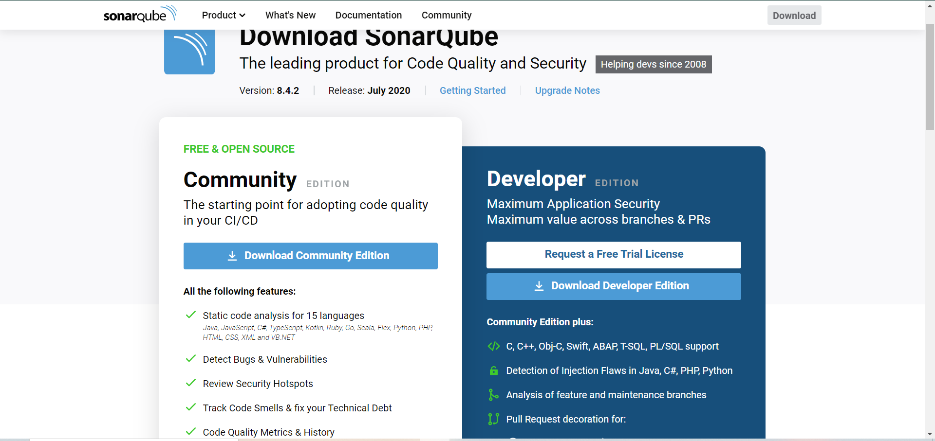

**Step-2:** Download is a zipped folder. Extract the folder.

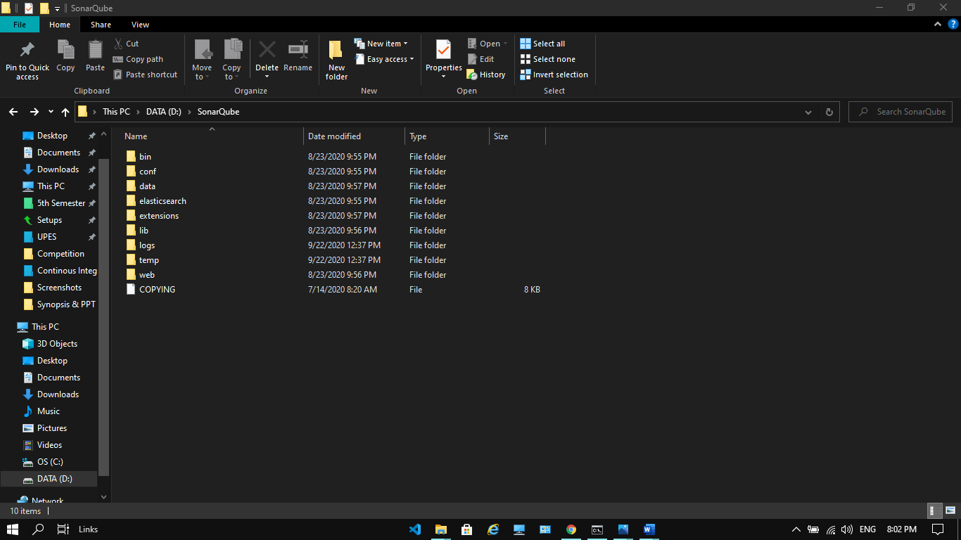

**Step-3:** use this path **“bin\windows-x86-64”** to go to the start sonar file

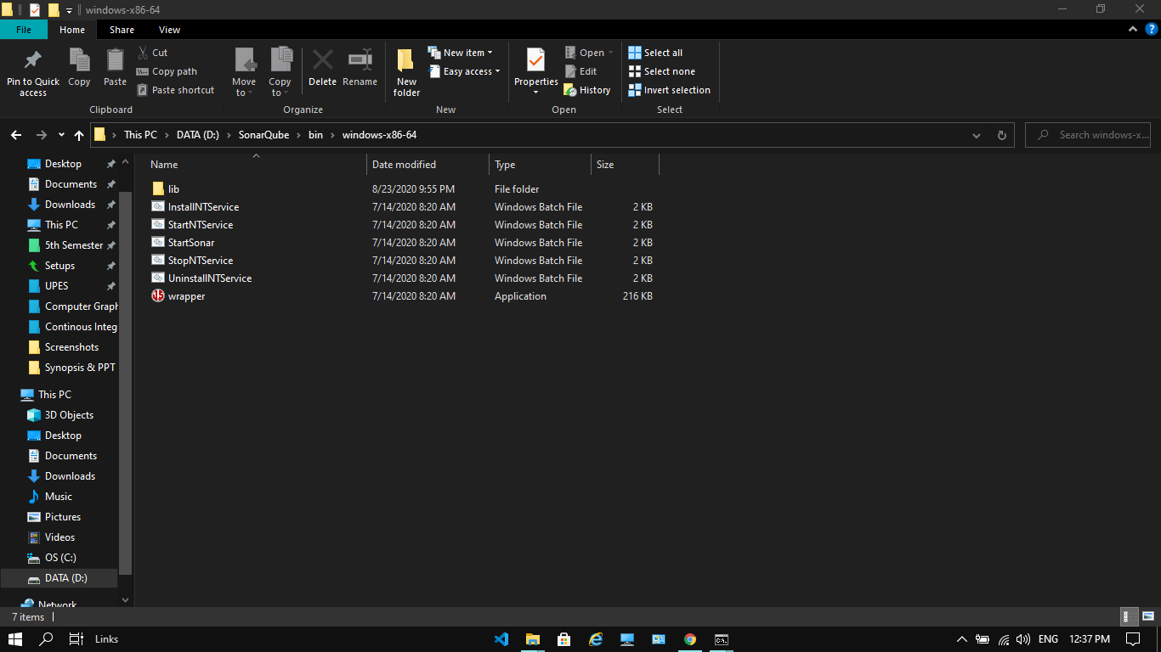

**Step-4:** type **“StartSonar”** to start SonarQube and type **“localhost:9000”** on the browser to start SonarQube.

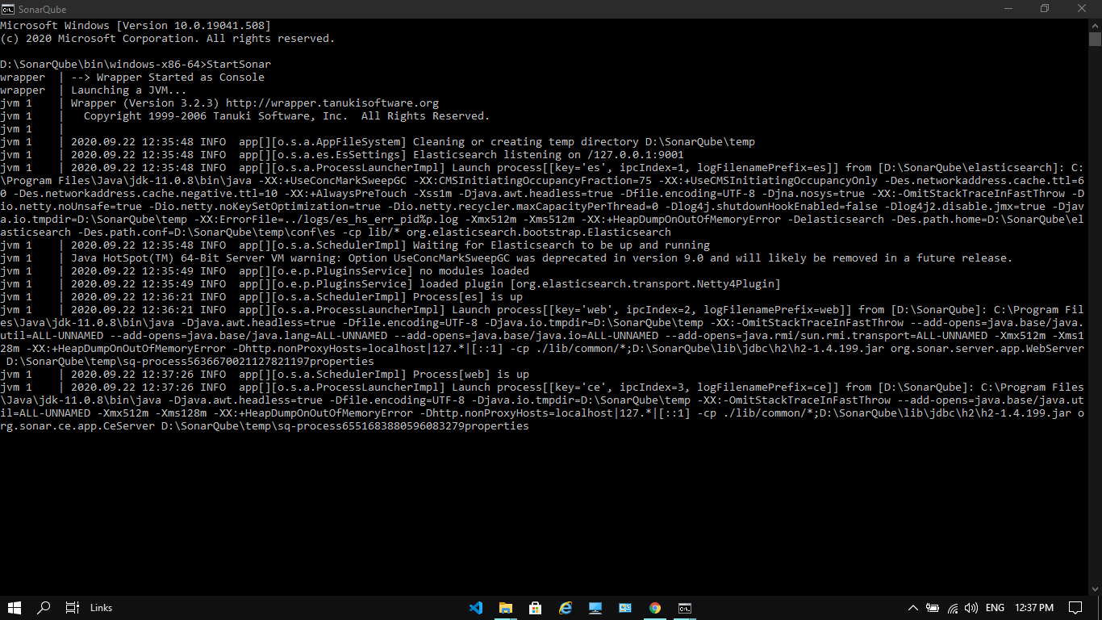

**Step-5:** Login to SonarQube and welcome window will appear.

